# Background and Related Work

E-commerce (electronic commerce) is the buying and selling of goods and services, or the transmitting of funds or data, over an electronic network, primarily the internet [1]. This chapter will be divided into 2 sections. The first section is background. In this section, the general features of the e-commerce platforms and the reasons why we choose to construct mobile e-commerce application will be interpreted. The second section concerns with the related work of the project. The comparison made with several mainstream will be illustrated in this section.

[1][Online]. Available: <https://www.techtarget.com/searchcio/definition/e-commerce>

## Background

Generally speaking, an e-commerce platform establishes an online market consisting of various stores. So, the primary features of these platforms are buying and selling. Different stores showcase their distinctive products and provide one-to-one online chat if customers have some questions with the specific product. Customers can search for the desired products or stores by simply typing their names into the search engine. After searching, customers are capable of using the filter to select more satisfying products. In the end, all the desired products can be checked out at one time. Here the shopping cart plays an important role. The platform provides a shopping cart where you can put satisfying products from different stores. In addition, payment is also a crucial feature of e-commerce platforms. Customers need to pay for the selected items and they can go through this process in several types. After the payment, the platform will store the information about the shipping process for a while until the order is completed. And the previous orders are all stored on the platform. Moreover, after the order is completed, the user can comment on the product and upload pictures, which can help other users to choose the product. In the following, we will illustrate the reasons why we choose mobile e-commerce applications.

According to statistics, the penetration rate of smartphones in China reached almost 72 percent and the total number of smartphone users has exceeded one billion in 2022[2]. In reality, it is essential for us to hold and use the smart phone everywhere. We use it to search for information, watch online video, or even pay through the 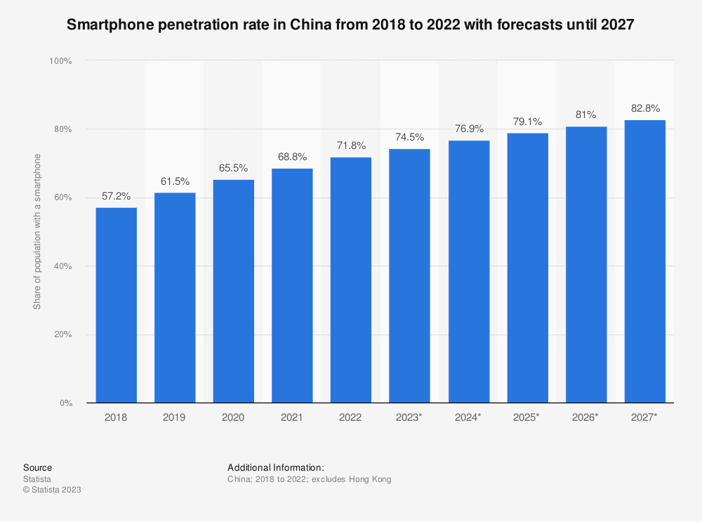mobile phone. Not exaggerate to say, we cannot live without smartphones.

Fig. : Bar chart about smartphone penetration rate in China

Where is your mobile phone now? It’s probably close to hand and that’s the case for a majority of smartphone users. Even if you are looking for something quickly on your phone, it is still highly possible for you to purchase some stuff resulting from random searching. So this is why mobile commerce is growing at such a dramatical rate: It is incredibly convenient.

Besides a fast-responsive and intuitive mobile app could shorten the time to purchase an item and give users immediate gratification. Because they only ought to tab on the screen with several actions to get the desired merchandising. The product will be shipped to their families in around two days. These two reasons why we are determined to develop a mobile application.

[2]<https://www.statista.com/statistics/321482/smartphone-user-penetration-in-china/>

[3] [Advantages of a Mobile Shopping Experience (imaginovation.net)](https://imaginovation.net/blog/advantages-of-a-mobile-shopping-experience/)

## Related Work

There are a lot of mobile online shopping malls in today’s world. The mainstream platforms are Taobao, JD.com and Amazon. They actually sell different kinds of products. But our mobile application mainly focusses on mobile phones. In the following, we would like to compare Niubility (our mobile application) with these platforms.

First of all, it is quite common for us to return to the same place when we are tabbing into detail page of a product in shopping cart and exit in these renowned platforms. Actually it is an efficient and convenient design for users. Same situations also happen in product list page, order list page, and so on. Niubility also has this function. Imagine the scenario, when a user is attracted by a product, he just goes into the detail page to obtain more information. When he exits, he is forced to return to the beginning point of the product list page if the application does not have this function. It is a waste of time for the user and may destroy the delighting experience of the user.

Secondly, these three online shopping malls acknowledge some data from other applications on the mobile phones and then analyze what product the user may like. It will recommend a list of items on the home page which is also an effective way to promote sales volume. Well, Niubility is just a simple mobile application which could not get any data from other applications on the mobile phones. But we thought this function was quite fantastic and intriguing. We actually write algorithm to do similar thing but require users to stamp some products as “like” or “dislike”. After get this information, Niubility will work as the same as the mainstream online shopping malls to recommend several distinctive products to the specific users.

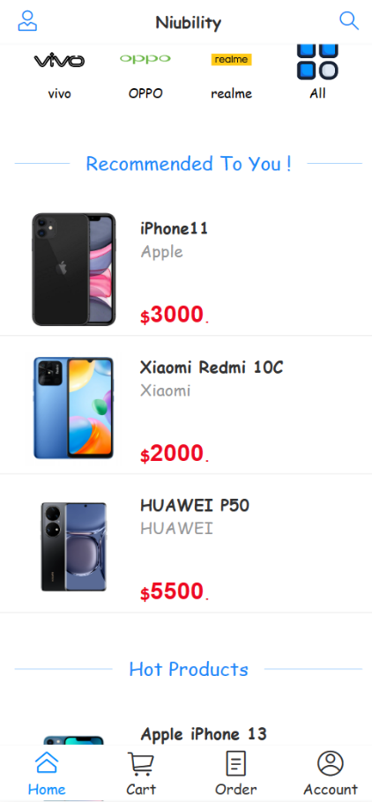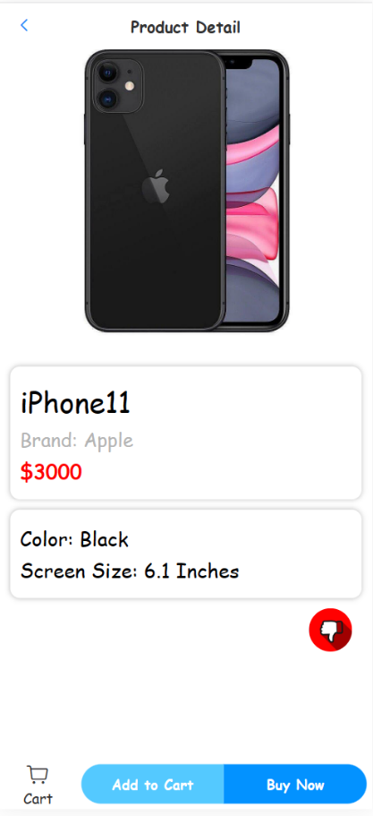

Fig . result of recommend algorithm Fig . a product stamped as “like”

Additionally, we consider the feature that the cart item on the bottom bar of home page can show the total number of products in the shopping cart is intuitive and efficient. Not only will this promote the shopping experience of customers because it could give customers an apparent view of the number of added items so that they are able to manage the content of shopping cart, but this will also stimulate the desire of customers to check out the products in shopping cart which will increase the sales volume further. During the comparison, we found JD.com and Amazon both have this feature, but for Taobao, it does not have this feature. Even though not all the mainstream platforms have this feature, we still it is crucial and necessary to contain the feature which will definitely promote the user-friendliness of our mobile application.

~~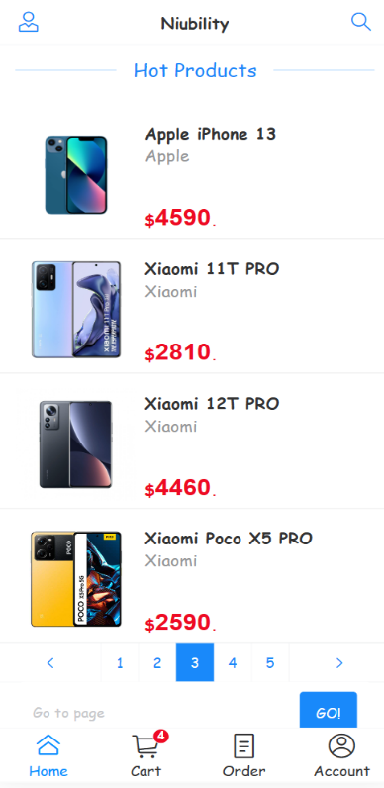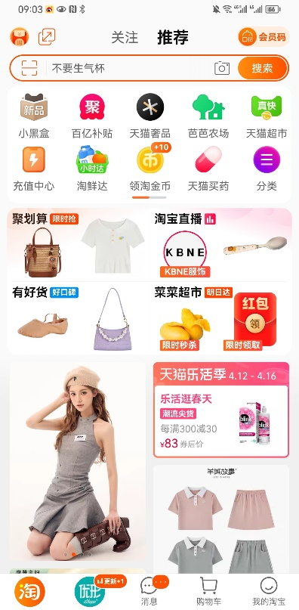~~

Fig. :Home page of Taobao Fig. :Home page of Niubility